***Synopsis of***

***Mini Project On***

**UniSync**

**Prepared By:**

Prithvi Kamlesh Yadav[55]

Sujay Shrinivas Shetty [61]

Shivam Santosh Yadav [52]

**Under the guidance of:-**

Mrs. Sonali Padalkar

**DEPARTMENT OF INFORMATION TECHNOLOGY**

**Academic Year: 2024-25**

**UNIVERSITY OF MUMBAI**

**CERTIFICATE**

## This is to certify that the following students:

Sr. No. Name of Student Roll No.

1. Prithvi Kamlesh Yadav 55

2. Sujay Shrinivas Shetty 61

3. Shivam Santosh Yadav 52

have submitted Mini-Project Report on *“UniSync”* as the partial fulfillment for the requirement of Second Year of Engineering (3rd Semester) in B.E. - Information Technology during the academic year 2024-25.

**Signature of Internal Examiner Signature of External Examiner**

**Date of Examination: _________________**

|  |  |
| --- | --- |
|  |  |
| **Dr. Roopali Lolage** | **Dr. Deven Shah** |
| **Head of Department** | **Principal** |
| **Department of Information Technology** |  |
|  |  |

**Table of Contents**

|  |  |  |
| --- | --- | --- |
| Chapter No | Topic | Page No |
| 1 | INTRODUCTION  1.1 Description  1.2 Problem formulation  1.3 Motivation  1.4 Proposed solution  1.5 Scope | 2  3  4  4  5 |
| 2 | REVIEW OF LITERATURE  2.1 Literature survey  2.2 Problem statement | 7  9 |
| 3 | SYSTEM ANALYSIS  3.1 Requirements  3.2 Use case diagram for proposed system | 11  13 |
| 4 | DESIGN  4.1 Flow chart | 24 |
| 5 | IMPLEMENTATION DETAILS  5.1 Implementation  5.2 Results | 28  43 |
| 6 | CONCLUSION  6.1 Conclusion  6.2 Future scope | 48  48 |
| 7 | REFERENCES | 50 |

## ACKNOWLEDGEMENT

A few sublime human experiences defy expressions of any kind, and a feeling of true gratitude is one of them. I, therefore, find words quite inadequate to express my indebtedness to my Guide **Prof. Swati Bhatt for her** virtuous guidance, encouragement and help throughout this work. Their deep insight into the problem and the ability to provide solutions has been of immense value in improving the quality of projects at all stages. This experience of working with them shall ever remain a source of inspiration and encouragement for me.

I express my thanks to **Dr. Roopali Lolage**, HOD (IT), SLRTCE, Mira Road, for extending her support that she gave truly helped the progression of the project work. I express my thanks to **Mrs. Swati Bhatt and Mrs. Surekha Mali** Asst. Prof., Mini Project Coordinators, SLRTCE, Mira Road for extending their support.

My sincere thanks to **Dr. Deven Shah**, Principal, and Dr. Umesh Bhadade, Vice Principal, SLRTCE, Mira Road for providing me the necessary administrative assistance in the completion of the work.

I am extremely grateful to the celebrated authors whose precious works have been consulted and referred to in my project work. I also wish to convey my appreciation to my friends who provided encouragement and timely support in the hour of need.

Special thanks to my Parents whose love and affectionate blessings have been a constant source of inspiration in making this a reality.

All the thanks are, however, only a fraction of what is due to the Almighty for granting me an opportunity and the divine grace to successfully accomplish this assignment.

**Member 1: Prithvi Kamlesh Yadav**

**Member 2: Sujay Shrinivas Shetty**

**Member 3: Shivam Santosh Yadav**

**Abstract**

In the digital age, the efficiency of administrative processes is crucial for the effective management of educational institutions. This project aims to transition the existing offline system of communication, fee processing, and complaint handling at our university to a robust online platform using Java. The current system is characterized by delays and inefficiencies that hinder the overall administrative workflow. By leveraging the capabilities of Java, this project will develop a comprehensive web-based solution to streamline these processes. The online system will facilitate real-time communication between students, faculty, and administrative staff, ensuring timely dissemination of information and feedback. An integrated fee processing module will allow for secure, fast, and convenient transactions, reducing the burden on both students and the finance department. These challenges not only lead to frustration among students and staff but also contribute to lost time and resources. By leveraging the capabilities of Java, this project will develop a comprehensive web-based solution to streamline these essential processes. The online system will facilitate real-time communication between students, faculty, and administrative staff, ensuring timely dissemination of important information, notices, and feedback.

**Chapter 1:**

**Introduction**

**Chapter 1: Introduction**

UniSync is a unified platform facilitating seamless communication between students and their universities. The platform provides students with a centralized location to manage essential academic and administrative tasks, such as fee management, complaint submissions, and viewing college details. By streamlining these processes, UniSync enhances accessibility and offers a user-friendly interface that connects students with institutional services more efficiently and transparently. The platform aims to improve the student experience by integrating core functionalities into one comprehensive system.

**Key Features:**

1. **Individual User Login:** Secure login system using Gmail, phone number, or other credentials to ensure data privacy and security.
2. **Complaint Management:** A dedicated 'Register a Complaint' button for students to submit grievances easily.
3. **Fee Tracking:** Students can view and manage fee records, with clear information on payment status.
4. **College Information Access:** Centralized access to institutional details, enhancing transparency and student engagement.
5. **Mobile-Friendly Interface:** Designed to be accessible on multiple devices, ensuring ease of use on both mobile and desktop platforms.

**1.1 Description**

In the above-proposed system, the first step is to create face databases as the match template for the system. A face database is created by acquiring a collection of people's photos. The photo should be half body photo where the face is facing the front. In the process of verification of ID for an image, the image that is captured using a digital camera will be processed. The image will be detected extracted and ready for the next stage. The next stage is pre-processing, where unnecessary features are eliminated. This is to reduce unnecessary processing effort. In the feature extraction, the images are collected from the database and represented as a vector, then the algorithm will find the average face vector or the mean and it will subtract the mean face from each sample face. All these photos then are processed using PCA procedures to get the Eigenface as the basis or standard features of the human face. These features will be used in the recognition phase.

**1.2 Problem Formulation**

In the context of educational institutions, effective communication and streamlined administrative processes are vital for ensuring a positive experience for students and staff alike. However, many universities continue to rely on traditional offline systems for communication, fee processing, and complaint handling, leading to several significant challenges:

**Inefficiency and Delays**: Current administrative processes often involve lengthy procedures, resulting in delays that frustrate students and hinder timely responses to inquiries or complaints.

**Limited Accessibility**: Traditional methods limit access to information and services, as students must often visit physical offices or rely on paper-based systems to manage their academic affairs, which can be inconvenient and time-consuming.

**Communication Barriers**: The lack of an integrated communication platform creates gaps in information flow between students, faculty, and administrative staff, leading to misunderstandings and delayed responses.

**1.3 Motivation**

Improving Efficiency: One of the primary motivations for this project is to enhance the efficiency of administrative processes within the university. By transitioning from manual, paper-based systems to a digital platform, the project aims to reduce processing times, eliminate redundancies, and streamline communication between students, faculty, and administrative staff.

Enhancing User Experience: The need for a user-friendly interface that students and staff can easily navigate is a strong motivation. A well-designed online system can significantly improve user satisfaction by providing a seamless experience for tasks such as fee payments, complaint submissions, and accessing important information.

Promoting Transparency: Transparency in administrative processes is crucial for building trust within the university community. By implementing a digital platform that allows for real-time updates and clear tracking of requests and transactions, UniSync aims to foster a more open and accountable environment.

**1.4 Proposed Solution**

The UniSync project proposes the development of a fully integrated, web-based platform designed to digitize and streamline the core administrative functions of universities. This solution will address inefficiencies in communication, fee management, and complaint handling, all through a user-friendly interface built using Java.

**1.5 Scope**

**Speed and Efficiency:** Online processes are typically faster than offline ones, reducing wait times for students and administrative staff.

**Convenience:** Students and staff can access services from anywhere with an internet connection, saving time and effort.

**Accuracy:** Online systems can reduce errors compared to manual processes.

**Accessibility:** Online platforms can cater to a wider range of students, including those with disabilities or those in remote areas.

**Cost-effectiveness:** Online systems can often be more cost-efficient than maintaining physical infrastructure.

**Chapter 2:**

**Literature Review**

**Chapter 2: Literature Review**

* 1. **Related Work**

As far as related works, the student self-service system in [11] is used to permit students to pay registration fees electronically via PayPal [5]. PayPal is a mediating service for online transactions that requires providing credit card or bank account details as the source of payments [1]. Moreover, the MUKOFPS system in [12] is introduced to allow paying university fees online using credit cards and debit cards. Besides, the application of online payment mode in university charging [13] is achieved by connecting with a third-party payment gateway and online banking. Also, the systems discussed in [14, 15] enable students to pay fees by interacting with a bank interface application allows users to register or link their profile. A mobile application guides the registration process where each user is asked to develop its personal profile by providing information, such as: Full Name, Telephone Number, Address, Phone Number, any Vegetarian preferences, any Allergies, Health status, Nationality and Religion. An alternative option to registration is to link an existing profile. In this case, the customer is asked to provide only the information that is missing to build a personal profile. This process is important since profiles are used during the recommendation process. From now on, we will refer to the information provided by each user as the user’s static information. We should note here that static information is updated automatically when users manually make changes on their profiles. Apart from user’s static information the system stores the user’s dynamic information; which are the most recent transactions, historical transactions, location of the most visited departments and products to buy.

* 1. **Problem Statement**

Administrative staff at the university are burdened with a high volume of manual tasks due to inefficient complaint handling, fee processing, and contact management systems. The lack of automation and integration in these processes results in increased workload, higher chances of errors, and slow response times.

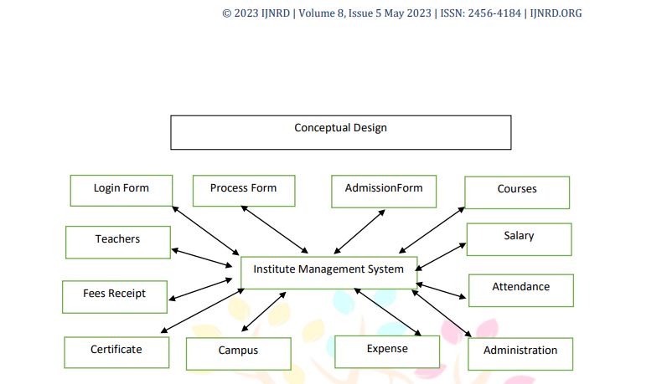

**(Dy patil Institute May 2023 Volume 8 pg. j482, INJRND.ORG)**

***(Conceptual design from above-cited reference.)***

**2.2 Existing System**

In most universities, administrative tasks such as complaint registration, fee management, and access to personal academic records are handled manually or through fragmented systems. Students often face difficulties due to inefficient communication channels, long processing times, and a lack of transparency in administrative processes. This can result in unnecessary delays and a frustrating experience for both students and university staff. Additionally, traditional systems lack the integration needed to provide a seamless, unified platform where students can manage all their academic and administrative needs in one place.

UniSync aims to address these challenges by creating a unified digital platform that streamlines university-student interactions.

UniSync is designed to address these inefficiencies by providing a unified digital platform that integrates all essential student interactions in one place. With UniSync, students will have access to a streamlined interface where they can easily register complaints, track fee payments, and access academic records. This approach not only simplifies the process for students but also improves the university's administrative operations. By eliminating the need for multiple systems and reducing manual processes, UniSync ensures faster and more accurate service delivery.

Furthermore, UniSync enhances communication between students and university administrators. When a student submits a complaint, for example, they can track its progress in real time, ensuring that issues are addressed promptly. This level of transparency creates a more accountable and responsive environment for handling student concerns. Similarly, the system's fee management feature allows students to view payment records, track upcoming dues, and avoid potential errors or delays in processing, making the experience far more convenient.

The introduction of such a system would also benefit university staff by reducing the administrative burden. Many tasks that were previously managed through manual entries, paper records, or multiple digital platforms can be automated or consolidated through UniSync. This frees up time for staff to focus on more important functions, such as providing academic support or addressing critical student issues. The platform ultimately fosters a more organized, accessible, and efficient environment for both students and university personnel.

UniSync promotes a more user-centric approach, ensuring that students can seamlessly interact with the university on a day-to-day basis. The integration of key functions into a single platform provides convenience and clarity, reducing confusion and delays.

**Chapter 3:**

**System Analysis**

**Chapter 3: System analysis**

**3.1 Functionalities**

**UniSync is built to streamline multiple administrative functions into a single, intuitive platform, making the university experience more seamless for students and staff alike. The platform integrates essential features such as complaint management, fee tracking, academic records, and personal information management. By bringing these functionalities together, UniSync eliminates the need for students to navigate multiple portals or rely on outdated systems that often cause delays and inefficiencies.**

**The primary goal of UniSync is to enhance both efficiency and accessibility within university administration. With a user-friendly design, students can easily access various services in one place, ensuring that they can manage their academic and administrative needs without hassle. It improves the student experience by reducing the time and effort needed to handle tasks like submitting complaints, checking fee records, or updating personal details.**

**One of the standout functionalities of UniSync is the complaint management system. This feature allows students to register complaints regarding university services, academic concerns, or any other issues directly from their dashboard. Once a complaint is filed, students can track its status in real-time, from submission to resolution. By giving students a clear overview of the complaint process, the platform ensures greater transparency and accountability on the university’s part.**

**Moreover, the system helps university staff manage complaints efficiently by providing a streamlined process for handling and resolving student issues. The automated tracking and structured response mechanism make it easier for both students and staff to maintain records, ultimately improving communication and ensuring faster resolution of problems. This functionality not only fosters a more responsive environment but also contributes to higher student satisfaction.**

**3.2 Case Diagram**



*(Dy patil Institute May 2023 Volume 8 pg. j482 , INJRND.ORG)*

**Chapter 4:**

**Design**

**Chapter 4:**  **Design**

**4.1 Flow chart**

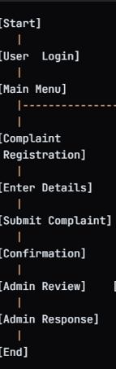

**--------> towards future addition of functionalities.**

**Chapter 5:**

**Implementation details**

**Chapter 5**

**5.1 Implementation**

The implementation of UniSync is a multi-layered process that involves integrating various components to create a seamless and efficient platform for students, university staff, and administrators. Each phase of the implementation focuses on delivering specific functionalities while ensuring the system’s scalability, security, and ease of use. Below are key aspects of the implementation:

* **Java-based Framework**: The core of the system is built using Java, leveraging its robustness, scalability, and security. Java ensures the smooth execution of server-side logic, which handles user authentication, request management, and data processing.
* **MySQL Database**: A MySQL database is integrated for storing all student records, fee information, complaint logs, and system logs. The relational structure of MySQL allows for efficient data retrieval and querying, ensuring system performance even as data grows.
* **System Testing**: The entire system is tested for integration, security, and performance to ensure all modules work seamlessly together and meet the required performance benchmarks.

**5.2 Result**

User-Friendly Experience -

Result: A well-designed dashboard that offers an intuitive experience for users, allowing easy access to academic records, fee payments, and other services. This will enhance user satisfaction and encourage more frequent use of university services.

Data-Driven Decision Making -

Result: The collection and analysis of user data through the platform will provide insights into student needs and behaviors. This can inform policy changes and improvements in university services, ultimately leading to a better educational environment.

Increased Operational Efficiency -

Result: Reduction in administrative workload through digitization of processes. This allows staff to focus on more strategic tasks rather than routine paperwork, leading to cost savings and improved service delivery.

Scalability and Future Enhancements -

Result: A modular design that allows for future enhancements and integrations with other systems or services, ensuring that UniSync can adapt to changing university needs over time.

**Input of our project :** 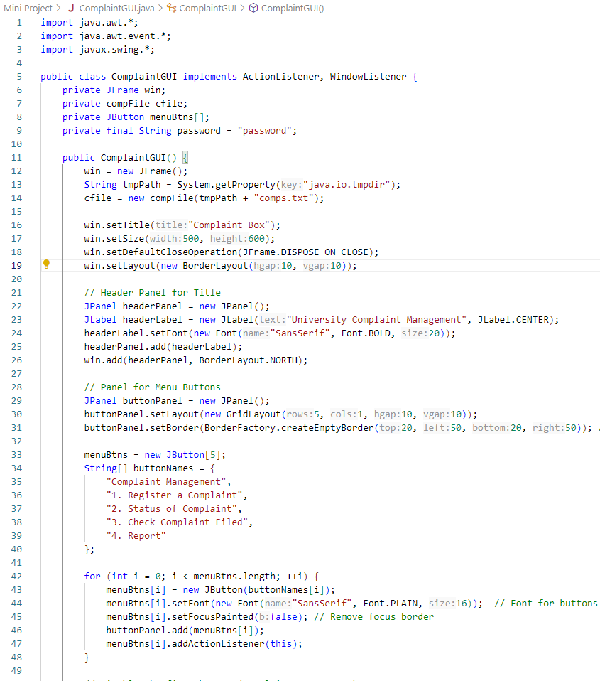

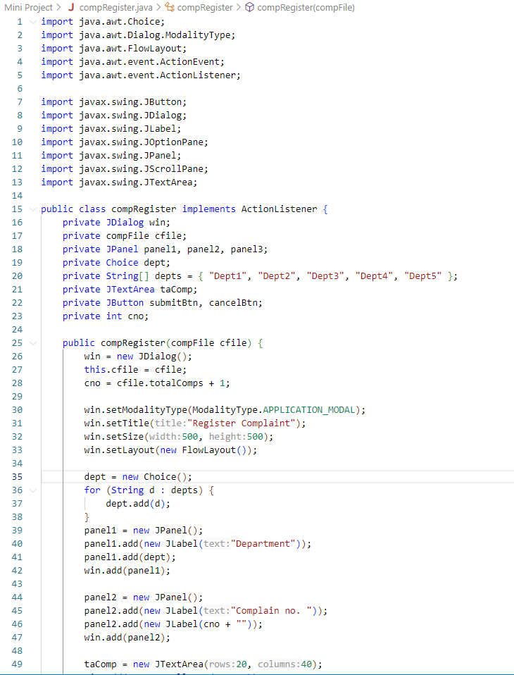

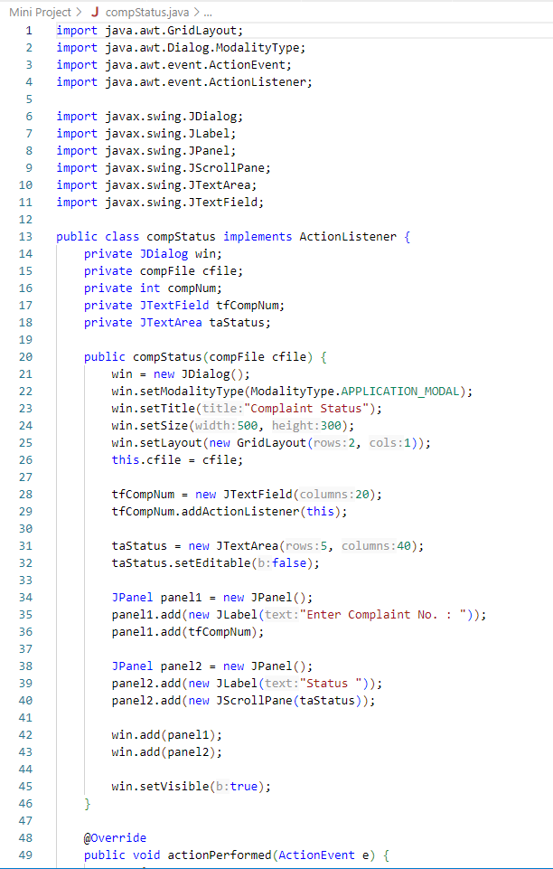

**Output of our project (***with functionality for registering complaints, etc.*)

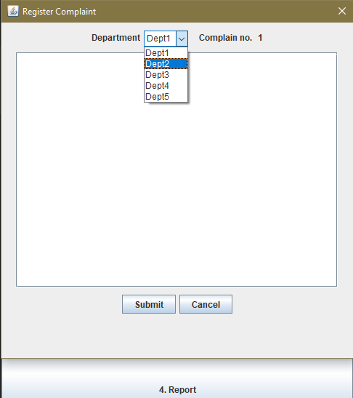

(*Complain registry with department info integrated within.*)

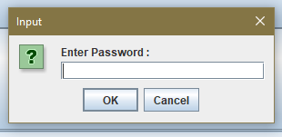

(*use of passkey/passwords for security and privacy of filed complaints*)

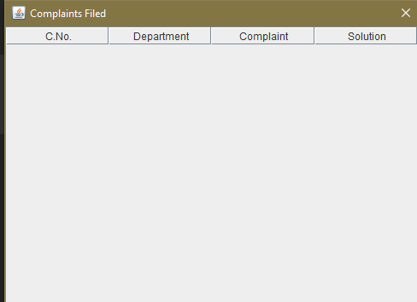

**(***Database connectivity i.e. any changes in the form of*

*Complaints will be stored here and the database simultaneously*)

**Chapter 6:**

**Conclusion**

**Chapter 6: Conclusion**

**6.1 Conclusion**

The UniSync project represents a transformative approach to modernizing the administrative functions of universities through a fully integrated web-based platform. By focusing on key areas such as communication, fee management, and complaint handling, UniSync aims to address existing inefficiencies while enhancing the overall student experience.

The implementation of a real-time communication platform will foster a connected and engaged university community, enabling seamless interactions among students, faculty, and administrative staff. The online fee management system will simplify financial transactions, reduce paperwork, and ensure timely payments, contributing to better financial transparency and record-keeping.

Additionally, the structured complaint management system will empower students to voice their concerns and track resolutions, promoting accountability and trust within the institution. Coupled with a user-friendly dashboard that centralizes access to essential services, UniSync will create an intuitive interface that enhances usability and satisfaction. In conclusion, UniSync not only offers a solution to current administrative challenges but also positions universities for future growth and adaptability. By leveraging technology to streamline processes, this project paves the way for a more efficient, responsive, and student-centric educational environment. The successful deployment of UniSync will ultimately contribute to the advancement of institutional effectiveness and improve the overall quality of education.

**6.2 Future Scope**

The UniSync project presents significant opportunities for future development and enhancement, ensuring that it remains relevant and effective in addressing the evolving needs of universities and their stakeholders. The following areas outline the potential future scope of the project:

**Mobile Application Development:**

The development of a mobile application can enhance accessibility, allowing students and staff to access services on-the-go. Features such as push notifications for important updates, fee reminders, and instant messaging can improve user engagement and responsiveness.

**Advanced Analytics and Reporting:**

Implementing advanced analytics capabilities will enable universities to derive insights from user data. These insights can inform decision-making, identify trends in student engagement, and improve service delivery. Customizable reporting features can assist administrators in monitoring various metrics related to academic performance, fee collection, and complaint resolution.

**Scalability for Other Institutions:**

The platform can be designed to be scalable, allowing its adoption by other educational institutions. Future developments may include tailored solutions for different types of institutions, such as colleges, universities, and vocational schools, expanding its market reach.

**Feedback and Continuous Improvement:**

Establishing mechanisms for user feedback will facilitate continuous improvement of the platform. Regular updates based on user suggestions and emerging educational trends will ensure that UniSync remains aligned with user needs and expectations.

**References**

[1] A. B. Chibuike, B. C. Nwoke, and L. Eleberi, *"An online departmental fee management system.”*

," *International Journal of Computer Science and Engineering (IJCSE)*

, vol. 20, no. 1, pp. 78-80, 2020. Available: <https://www.ijcseonline.org/pub_paper/20-IJCSE-07830-1.pdf>.

[2] *"Design and implementation of online student registration portal," Scribd*.

Available: <https://www.scribd.com/document/432352134/Design-and-Implementation-of-Online-Student-Registration-Portal>.

[3] G.-A. Istrate, R. A. Budu, and C. A. Popa, "*Institutional communication in the digital age," ResearchGate, 2022.*

Available: <https://www.researchgate.net/publication/365279826_Institutional_communication_in_the_digital_age>.

[4] "Implementation of online registration portal," *International Journal of Emerging Research in Technology*,

vol. 13, no. 7, pp. 1-10, 2022. Available:

https://www.ripublication.com/irph/ijert20/ijertv13n7_36.pdf.

(By IEEE format)

**Report of the project UniSync ends here.**